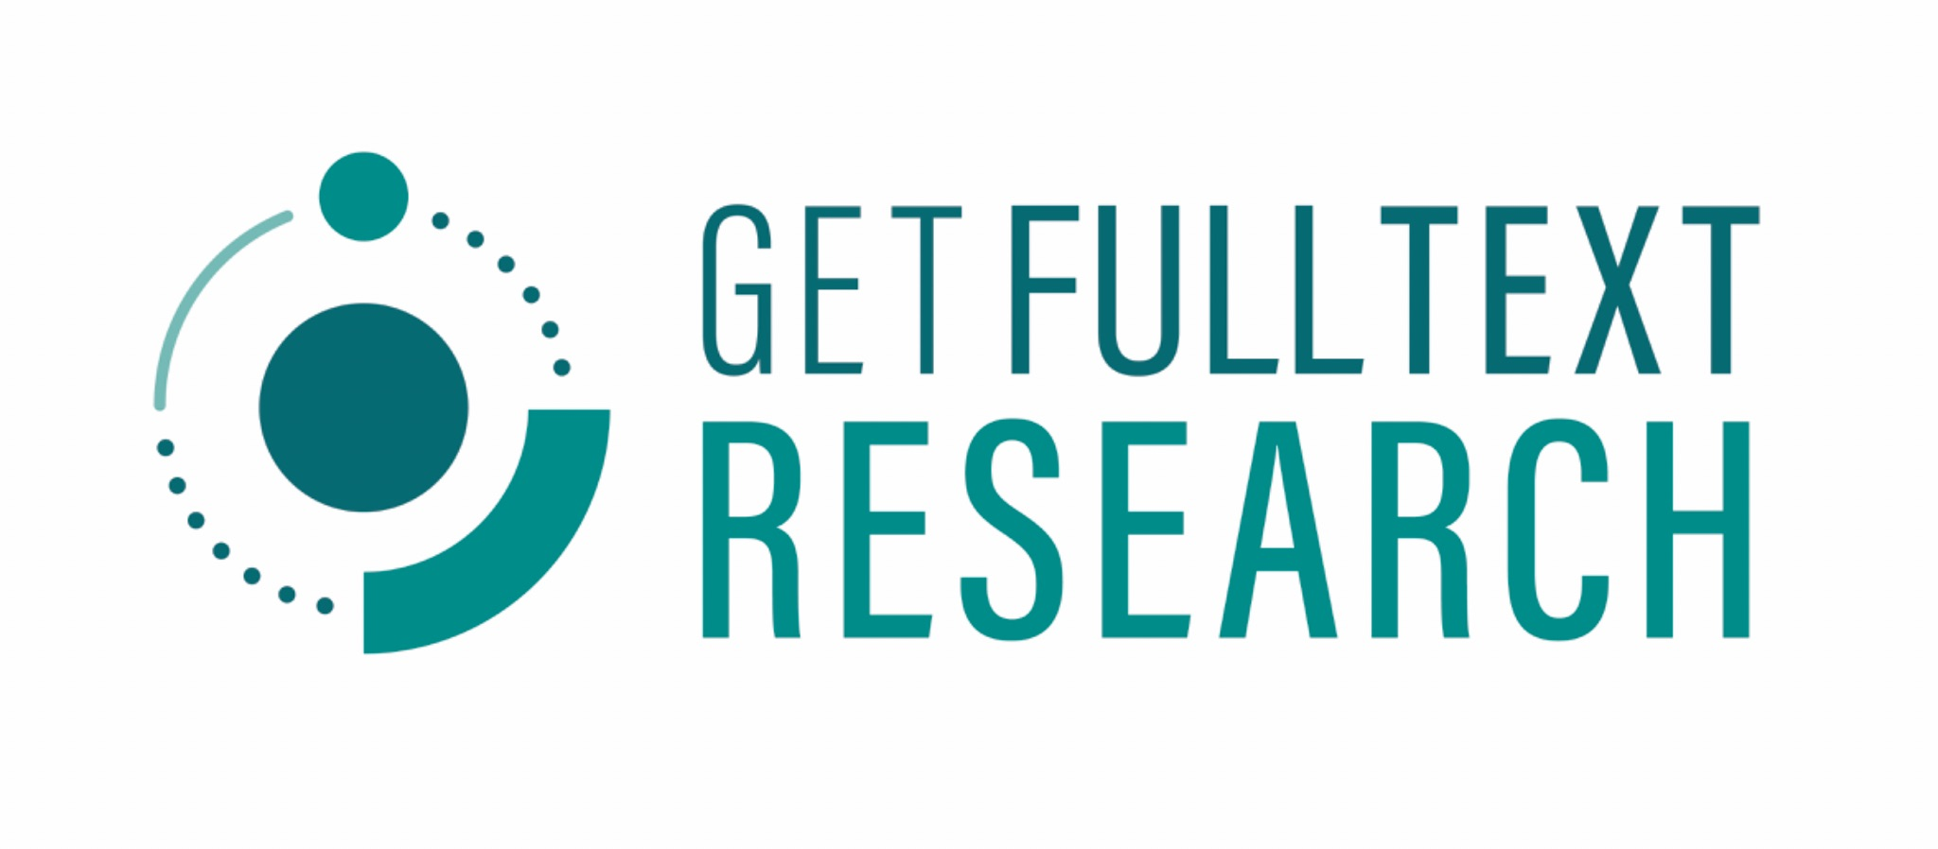

GetFTR Browser Extension Promotional Copy for Publishers

**Information page with general copy and screen shots:** <https://www.getfulltextresearch.com/getftr-browser-extension>

**Links to stores:**

* Chrome: <https://chromewebstore.google.com/detail/get-full-text-research-ge/kkppafkhgdfhkonclhdchdfhmldamiof?pli=1>
* Firefox: [Get Full Text Research (GetFTR) – Get this Extension for 🦊 Firefox (en-GB)](https://addons.mozilla.org/en-GB/firefox/addon/getftr-extension/?utm_source=addons.mozilla.org&utm_medium=referral&utm_content=search)
* Edge: [Get Full Text Research (GetFTR) - Microsoft Edge Addons](https://microsoftedge.microsoft.com/addons/detail/get-full-text-research-g/agkgbmolkihnoffbpiglifaipnjlahbl)

## **Standalone Email to Researchers:**

**Subject: Get Fast, Reliable Access to Trusted Content with GetFTR**

Dear [Researcher’s Name],

[Publisher Name has partnered with GetFTR/is a founding partner of GetFTR] and would like to share news about a tool which will help you maximize your research efficiency. The **free GetFTR Browser Extension has been** designed to help you quickly access the scholarly content you’re entitled to read, and highlight retraction and errata information at the point of discovery:

* **Easily identify full-text articles** available through your institution or open access
* **Smart links** that take you directly to trusted, published content
* **Stay informed** with retraction and errata details at the point of discovery

**Where does it work?**

✔ On all websites that use DOIs—search engines, academic discovery tools such as PubMed,academic search engines such as Google Scholar, social media, news sites, library discovery tools, and many more.  
✔ On leading preprint platforms like Preprints.org, OSF.io, ArXiv, ChemRxiv, BioRxiv, and SSRN, linking preprints to the published Version of Record.

Researchers can easily access the trusted and up-to-date content they are entitled to read directly from their favourite discovery resource or website; and view information on retraction and errata at the point of discovery.

* *“This is so cool! I just pulled up Google Scholar to test this out, and I love that it mentions if it’s” open access or subscription”*

The **GetFTR Browser Extension is free** to install and works with **Chrome, Firefox, and Edge** (Safari coming soon).

**📥 Download now: (links above)**[Chrome Store] | [Firefox Store] | [Edge Store]

## **Newsletter Blurb aimed at Researchers:**

**Fast, Instant Access to Trusted Research with GetFTR**

The **free GetFTR Browser Extension** makes it easier than ever to access the scholarly content you’re entitled to read. It works on all websites that use DOIs—academic search engines such as Google Scholar, academic discovery tools such as PubMed, search engines, social media, news sites, library discovery tools, and more—and connects preprints to the published Version of Record.

* Instantly identify full-text articles available through your institution or open access
* Navigate directly to trusted content with smart links
* Stay informed with retraction and errata information at the point of discovery

The extension is **free** and works with **Chrome, Firefox, and Edge** (Safari coming soon).

**📥 Download now:** [Chrome Store] | [Firefox Store] | [Edge Store]

## **Social Media Posts**

**Ever clicked on a link to the research you need, only to be told you can’t read the full text? Would you like to know if an article has been retracted or corrected before you go to the article. If so, you need the free GetFTR Browser Extension!**

No more guessing if you have access to the must up to date and trusted research—**GetFTR** makes it easy.

✅ **Instantly see** which articles you can read through your institution or open access  
✅ **Smartlinks** straight to trusted, published content  
✅ Have confidence with up to date **retraction and errata information**

Works on **Chrome, Firefox, and Edge** (Safari coming soon) and supports major research & preprint platforms.

🔗 **Download for free now!** [Chrome Store] | [Firefox Store] | [Edge Store]

**GetFTR: Fast, Reliable Access to Trusted Content**

#GetFTR #OpenAccess #AcademicResearch #ResearchTools #ScholarlyPublishing #ResearchIntegrity

## **Email to librarians**

**Subject Help Your Patrons Access Trusted Research More Easily with GetFTR**

Dear [Librarian’s Name],

[Publisher Name has partnered with GetFTR/is a founding partner of GetFTR] and would ike to share news about a tool which will help researchers maximize their research efficiency.

The **free GetFTR Browser Extension** is designed to ensure your patrons get **fast, reliable access to trusted content.** The extension helps researchers make the most of your library’s subscriptions while ensuring they find the most **accurate, up-to-date** content.

* **Streamlined access** – Patrons instantly see which articles they can read through your institution or open access
* **Smartlinks** – Direct researchers straight to the Version of Record, reducing frustration and wasted time
* **Retraction & errata alerts** – Ensures researchers rely on only the most **accurate and current** findings and can view that information at the point of discovery
* **Library transparency** – Patrons can see information about your institution’s subscription or open access availability (institutional information is given in the hover state)

The **GetFTR Browser Extension is free**, works with **Chrome, Firefox, and Edge** (Safari coming soon), and integrates with major research & preprint platforms.

📥 **Encourage your patrons to download it today!**[Chrome Store] | [Firefox Store] | [Edge Store]

**GetFTR: Fast, Reliable Access to Trusted Content**

## **Blurb for publishers to put in librarian newsletter**

**Get Fast, Reliable Access to Trusted Content with the GetFTR Browser Extension**

Put a stop to “click and pray” scenarios—ensure **fast and trusted access** to full-text research with the **free GetFTR Browser Extension**!

* Instantly see which articles are available through your institution or open access
* Get **smart links** straight to trusted, published content
* Stay informed with **retraction and errata information at the point of discovery**
* See library subscription & open access details before you click

The extension is **free** and works with **Chrome, Firefox, and Edge** (Safari coming soon).

📥 **Download now:** [Chrome Store] | [Firefox Store] | [Edge Store]

# 